Dmitrii Ponomarev

Ec22805@qmul.ac.uk

Abstract

This report presents a comprehensive analysis of global intelligence, exploring the relationships between average IQ scores and a spectrum of socio-economic indicators across continents. Leveraging a dataset encompassing variables such as IQ, Continent, Literacy, HDI, School Years, GNI, and Population, the study employs statistical and visual analyses to unravel patterns and correlations within the data.

Global IQ analysis

Table of Contents

Table of abbreviations 1

Chapter 1 Introduction 1

Description 1

Hypothesis 1

Data Overview 2

Data limitations 2

Chapter 2 Unit testing 3

Chapter 3 Data analysis 4

Distribution of IQ 4

Average IQ and Human Development Index 5

Average IQ and Gross National Income 6

GNI and average time spent in school 6

GNI and Literacy 7

Chapter 4 Conclusion 8

Chapter 5 Table of figures 8

Chapter 6 References 8

# Table of abbreviations

|  |  |
| --- | --- |
| Abbreviation | Definition |
| HDI | Human development Index |
| GHI | Gross National Income |
| IQ | Intelligence Quotient |
|  |  |

# Introduction

## Description

Curios about what variables influence a person's intelligence, I scoured the web for datasets that would assist me identify patterns to answer questions about the distribution of IQ and what characteristics influence it.

The reasoning behind choosing this dataset is based on the belief that a detailed knowledge of the counties' aspects may provide insight into the complex relationships that exist between development, education, and general well-being of citizens. Through examining metrics like life expectancy, the HDI, literacy rates and others we hope to find relationships and trends that contribute to a more comprehensive understanding of a country's position in the world.

## Hypothesis

There is a correlation between intelligence, as measured by average IQ scores, and a variety of socioeconomic factors, including literacy rates, the HDI, educational attainment (School Years), and GNI.

## Data Overview

After removing erroneous and null data, I was left with 179 countries that had information about their region, which can be seen in figure 1.

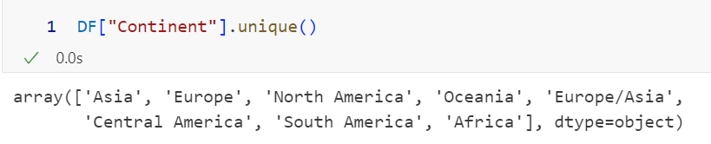

Figure - Regions in the data set

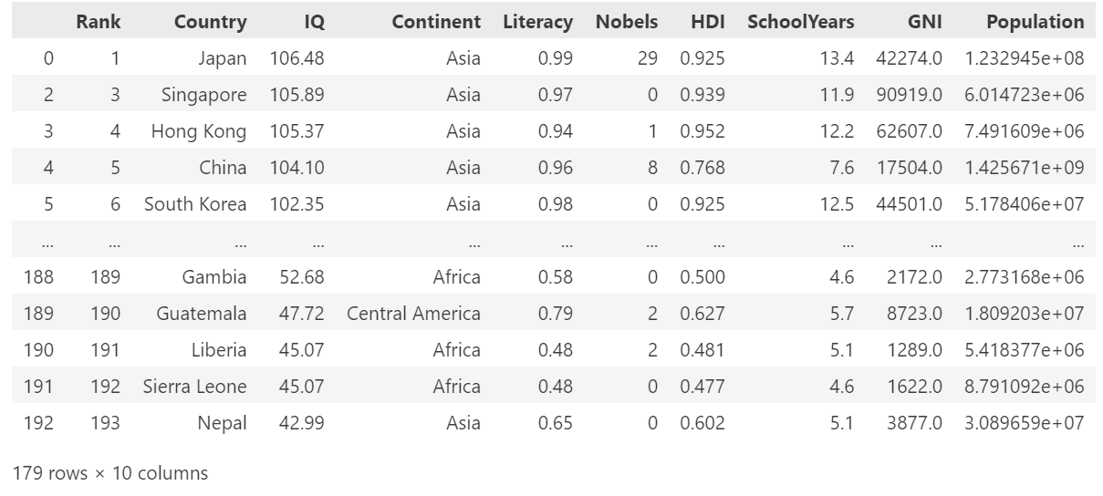

Table - Dataset example

### Data limitations

Unfortunately, the dataset has not been updated completely and includes data from 2021 (the HDI and GNI) that were taken from an earlier dataset that the same person published in 2021. In order for my conclusions to be legitimate, I have to assume that both of these parameters haven't changed significantly since then.

Although asking everyone on the planet for their IQ and unique living characteristics would be valuable for a thorough examination, it is both impractical and impossible. To overcome such limitations and provide a representative sample, using pre-made datasets from reliable sources such as the UNDP website and others becomes a practical alternative. These datasets are selected, providing a broad comprehensive overview of many countries, allowing for a more efficient and viable examination of socioeconomic variables without the enormous work of evaluating each individual.

# Unit testing

# Data analysis

Figure 2 shows how the average IQ of different countries varies noticeably. There is a significant gap between a first-world country like the United States, where the average IQ is 99.52, and a third-world country like Ghana or Togo, where the average IQ is 58.16 and 59.83, respectively.

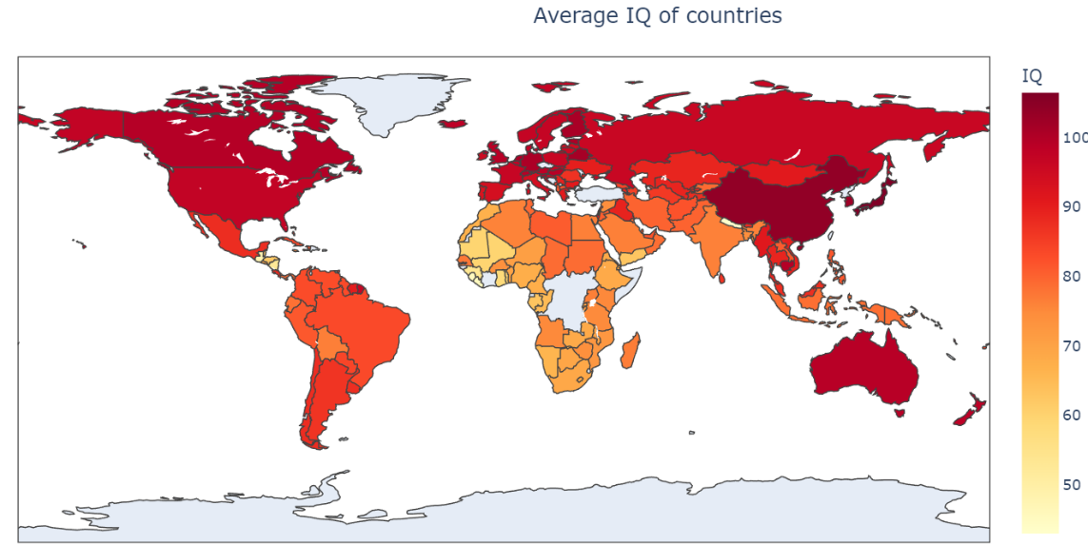

Figure - Coloured world map with countries' IQ

We cannot draw the conclusion that a continent significantly influences average IQ levels since, within Asia, IQ values differ significantly between India and China (76.24 and 104.1, respectively).

## Distribution of IQ

On Figure 3 we can see the distribution of average IQ of the whole world. The histogram shows an average IQ of the whole world according to the dataset being 82 points. By investigating closer by separating into regions, we can clearly see that North America has the highest average IQ amongst all other regions. It is important to notice, that even though North America has the highest IQ on average, the country with the highest IQ on average is China located in Asia.

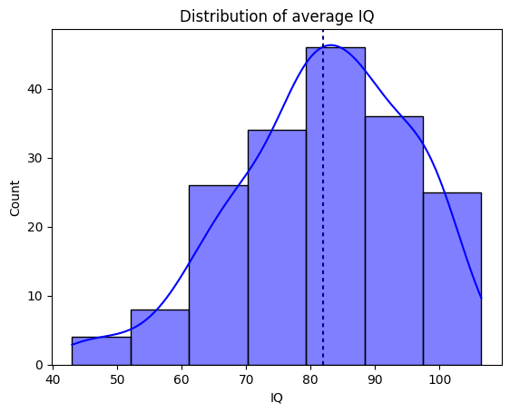

Figure - Distribution of average IQ

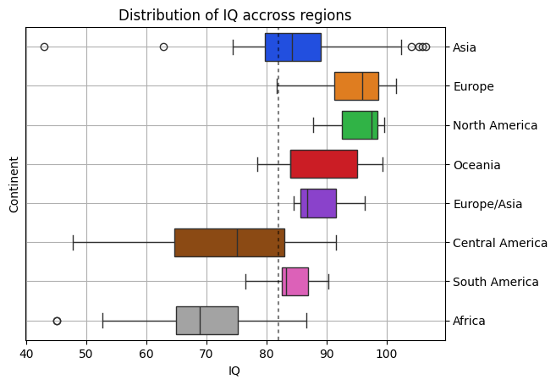

Figure - Distribution of IQ for every region

## Average IQ and Human Development Index

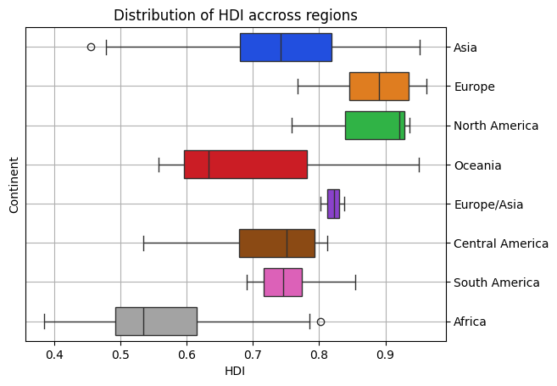

Figure - Distribution of HDI across regions

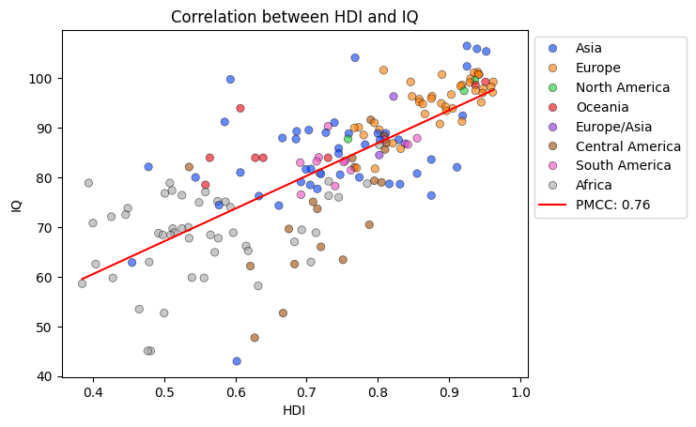

Figure - Correlation between HDI and IQ coloured by region

To understand how HDI affects IQ, we must examine how it varies by area. Figure 5 shows that Asia has the greatest differences, implying that nations there do not have equitable distributions of income, life expectancy, or mean years of schooling. Blue dots on Figure 6 support this, ranging from 0.455 in Yamen to 0.952 in Hong Kong. It's important to consider that, despite their 0.496-point gap, Honk Kong, and Yamen each have one Nobel Prize recipient.

Apart from the Europe/Asia area, which includes Georgia, Russia, and Turkey, North America has the least spread and the greatest HDI, indicating that people in North America will have a better life than those in Africa, which has the lowest HDI across nations on average.

## Average IQ and Gross National Income

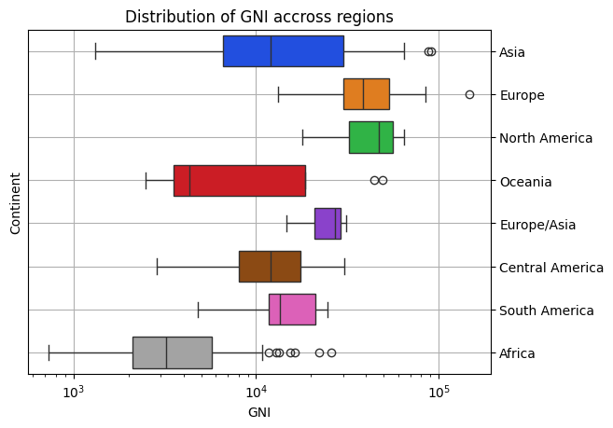

Figure - Distribution of GNI across regions

Figure 7 shows that the top three areas with the greatest GNI are North America, Europe, and Europe/Asia. This indicates that these regions have the highest average gross national income, which suggests that the nations in these regions probably have more spare revenue that might be used for higher education.

As we can see, except for the Seychelles, which is a popular tourist destination, Mauritius, which offers offshore banking and agriculture, Botswana, which offers tourism and agriculture, Libya, which produces crude oil, and other countries, Africa tends to be a less fortunate continent with few instances of both internal and foreign trade.

### GNI and average time spent in school

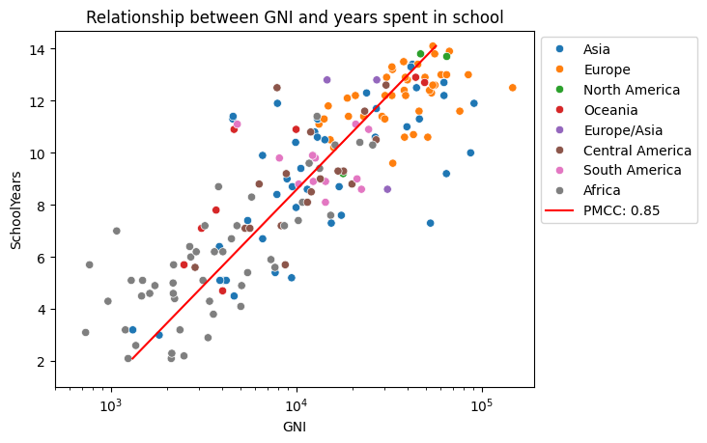

Figure - Relationship between GNI and years spent in school

Figure 8 clearly shows the relationship between the total income of the country and the number of years its people attended school. We can see distinct regional clusters, with Europe and North America in the first quadrant, indicating that families in those regions, on average, have more spare income and can afford to spend it on secondary education. In contrast, counties in Africa and Asia have lower total income, indicating that governments are unwilling to spend more on education because doubling the number of years a student can spend in school would require ten times the amount of money that is needed (Korolivska, 2019).

# Conclusion

Country has more income -> people have more spare income -> able to spend more on education -> higher IQ on average

Use ReadMe. Use libraries and all

Unittest for plots (saved as jpeg?)

Gold standard: When we simulate, pipeline should return correct values

Code separate from test suite

Test suite for reading data?

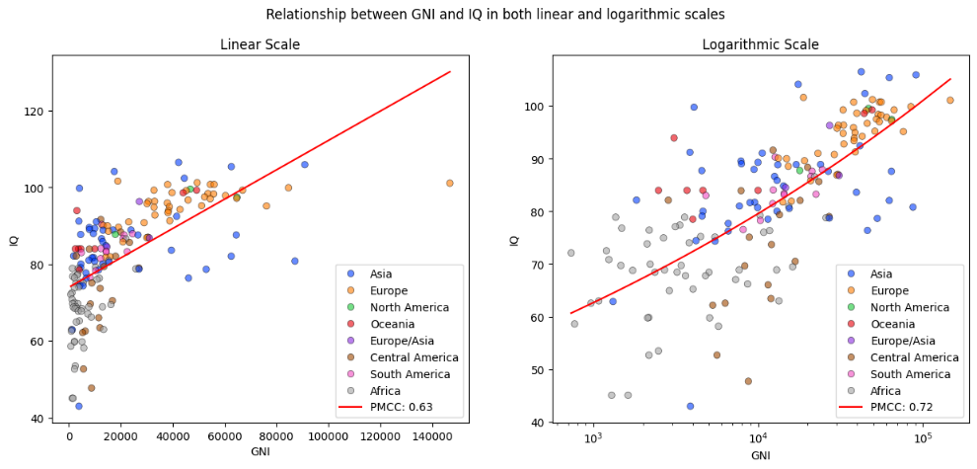

Figure - Correlation between GNI and IQ coloured by region

# Table of figures

[Figure 1 - Regions in the data set 2](https://qmulprod-my.sharepoint.com/personal/ec22805_qmul_ac_uk/Documents/Documents/Year%202/Software%20Practices/ProfessionalSoftwareModule/Coursework/Report/Report%20(2).docx#_Toc153384013)

[Figure 2 - Coloured world map with countries' IQ 4](https://qmulprod-my.sharepoint.com/personal/ec22805_qmul_ac_uk/Documents/Documents/Year%202/Software%20Practices/ProfessionalSoftwareModule/Coursework/Report/Report%20(2).docx#_Toc153384014)

[Figure 3 - Distribution of average IQ 4](https://qmulprod-my.sharepoint.com/personal/ec22805_qmul_ac_uk/Documents/Documents/Year%202/Software%20Practices/ProfessionalSoftwareModule/Coursework/Report/Report%20(2).docx#_Toc153384015)

[Figure 4 - Distribution of IQ for every region 4](https://qmulprod-my.sharepoint.com/personal/ec22805_qmul_ac_uk/Documents/Documents/Year%202/Software%20Practices/ProfessionalSoftwareModule/Coursework/Report/Report%20(2).docx#_Toc153384016)

[Figure 5 - Distribution of HDI across regions 5](https://qmulprod-my.sharepoint.com/personal/ec22805_qmul_ac_uk/Documents/Documents/Year%202/Software%20Practices/ProfessionalSoftwareModule/Coursework/Report/Report%20(2).docx#_Toc153384017)

[Figure 6 - Correlation between HDI and IQ coloured by region 5](https://qmulprod-my.sharepoint.com/personal/ec22805_qmul_ac_uk/Documents/Documents/Year%202/Software%20Practices/ProfessionalSoftwareModule/Coursework/Report/Report%20(2).docx#_Toc153384018)

[Figure 7 - Distribution of GNI across regions 6](https://qmulprod-my.sharepoint.com/personal/ec22805_qmul_ac_uk/Documents/Documents/Year%202/Software%20Practices/ProfessionalSoftwareModule/Coursework/Report/Report%20(2).docx#_Toc153384019)

[Figure 8 - Relationship between GNI and years spent in school 6](https://qmulprod-my.sharepoint.com/personal/ec22805_qmul_ac_uk/Documents/Documents/Year%202/Software%20Practices/ProfessionalSoftwareModule/Coursework/Report/Report%20(2).docx#_Toc153384020)

[Figure 10 - Correlation between GNI and IQ coloured by region 7](https://qmulprod-my.sharepoint.com/personal/ec22805_qmul_ac_uk/Documents/Documents/Year%202/Software%20Practices/ProfessionalSoftwareModule/Coursework/Report/Report%20(2).docx#_Toc153384021)

[Table 1 - Dataset example 2](https://qmulprod-my.sharepoint.com/personal/ec22805_qmul_ac_uk/Documents/Documents/Year%202/Software%20Practices/ProfessionalSoftwareModule/Coursework/Report/Report%20(2).docx#_Toc153384008)

# References

Mlippo, 2023. *Average global IQ per country with other stats.* [Online]   
Available at: 25  
[Accessed https://www.kaggle.com/datasets/mlippo/average-global-iq-per-country-with-other-stats November 2023].